******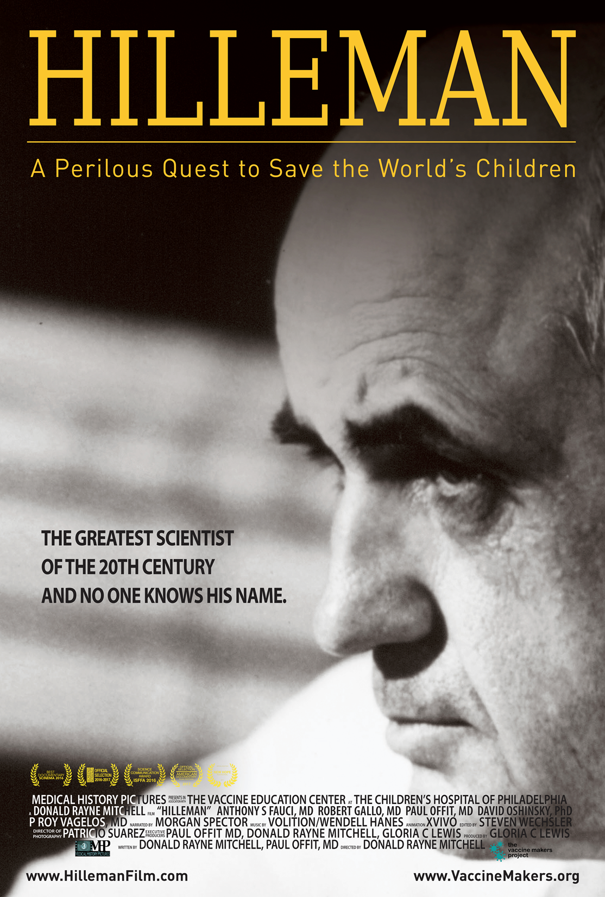

**[Place your school logo here]**

**The Vaccine Makers Project**

**@vaccinemakers**

**[Screening day,**

**date and time]**

**[Event description, including any guests]**

**[Location]**

**www.Vaccine.chop.edu**